Google Chrome Crashes using Uber Conference Share Screen

Steps to duplicate the error:
- Uber Conference
  - https://www.uberconference.com
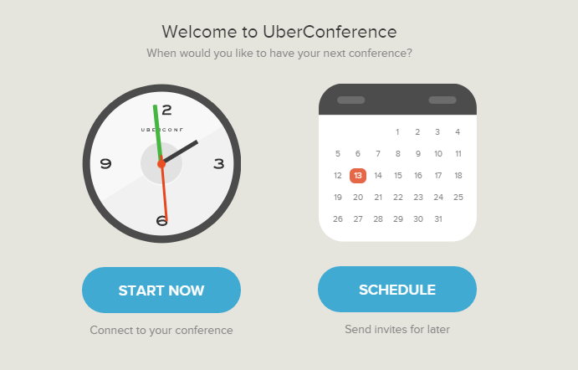

- Select “Start Now”
- Under “Use Your Computer” Select “I’m Just Viewing”
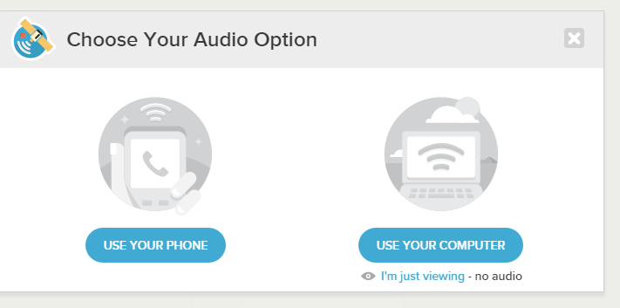

- Select “Share” from the left hand corner of the screen
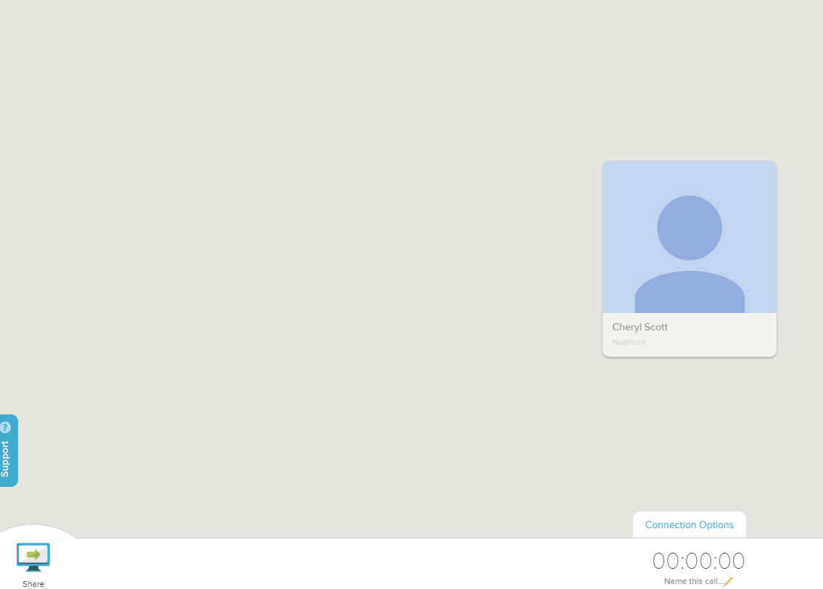

- Select “Share Your Screen”
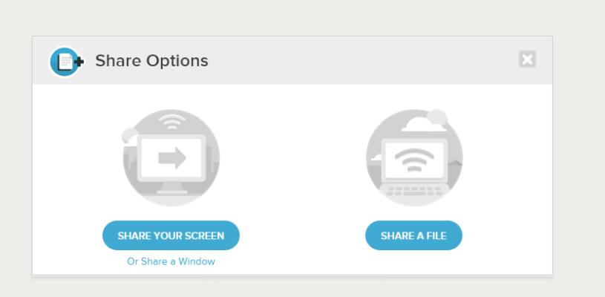

- Select “Screen 1”
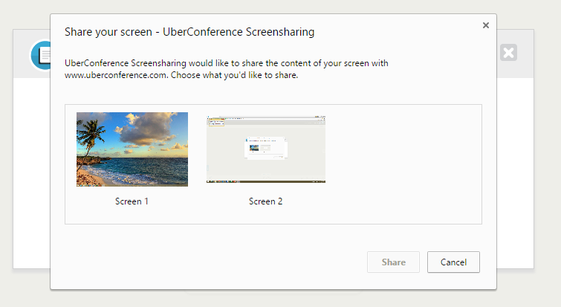

- Upon selection of “Screen 1 and then Share” you receive the following error and Google Chrome crashes. All applications in use terminated. 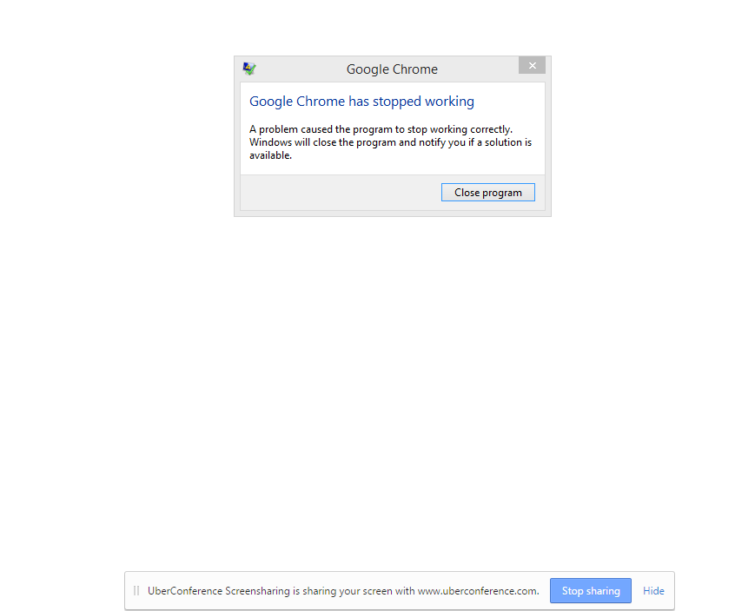

NOTES:
My co-workers are using the sharing feature with no problem. This problem has been reported to both Google and to Uber on 6/29 and multiple times since with no resolution. My IT person has done everything to help get this error corrected with no support from either company.
Version of Chrome:
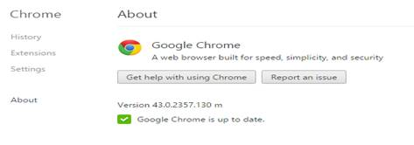

OS – Windows 8

Extensions:



